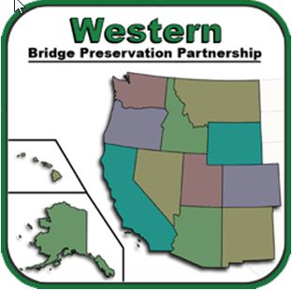 | WBPP  AGENDA | Western Bridge Preservation Partnership  Date: February 2nd, 2022  Time: 11:00 – Noon (PST)  Connection Info Below
Time | Topic | Presented By
11:00 | Welcome / Introductions / Approval of Meeting Minutes | Andrew Blower
11:05 | Working Group:  - Local Agency Outreach  - Bridge Deck Preservation  - Bridge Inspection | Working Group Chairs
11:20 | Technical Presentation  - External Post Tensioning of Structures Using CFRP Composites | Eri Vokshi and Marcel Rey
11:55 | Administrative items / New Business / Current Budget / Travel / Annual Meeting | All
12:00 | Adjourn
GoTo Meeting Link:

1. Please join my meeting.
https://www3.gotomeeting.com/join/305841766
2. Use your microphone and speakers (VoIP) - a headset is recommended. Or, call in using your telephone.
Dial +1 (213) 493-0603
Access Code: 305-841-766
Audio PIN: Shown after joining the meeting
Meeting ID: 305-841-766
Next Meeting: March 2nd, 2022 11:00 AM PST

Technical Presentation:

External Post-tensioning of Structures Using CFRP Composites

External post-tensioning of structures is a well-established and understood strengthening method for bridges, buildings, and industrial structures. Fiber reinforced polymers (FRP) are a proven technology for upgrading and strengthening concrete, masonry, timber and steel structures. FRP systems can also be post-tensioned to provide active strengthening. This presentation will describe successful installation of external post-tensioned FRP systems, anchoring methods, and design considerations. Typical applications of this strengthening method include flexural reinforcement, seismic upgrades, change in use, and building alterations.

