Weathering Steel Notes
- The group discussed the Fern Hollow Bridge Collapse in Pittsburg. Weathering steel is not completely immune to the environment elements still needs proper maintenance and inspection. Corrosion was the main issue with this structure and could have been prevented.

- Chicago and other state have made the point to still paint weather steel at trouble areas for additional protection. This includes girders ends and elements beneath joints etc.

- Minnesota noted they had difficulty identifying which structure in their system had weathering steel. Implemented new coding to differentiate from other steel structures.

- SD had a few local system bridges with weathering steel that didn’t follow FHWA guidance. (Example: weathering steel bents in water). Local agencies may not be aware of guidance for uses of weathering steel. Counties take advice from consultants.

- Emphasized again that weather steel issues usually due to low maintenance; clean structures, remove vegetation etc.

- Noted that inspector recommendations are not mentioned in NBI training course.

- Railroads prefer weathering steel however not always applicable in area. West Virginia DOT has weathering steel delaminated due to poor application uses. Need more education on subject.

- South Dakota has had issues with the type 3 bolts flaking on splice plates at one end of a structure with no other elements including splice plate affected. Bolts in splice plates at the other end of structure don’t have this issue. The cause is being investigated.

- Deck steel is more expensive up front however secondary cost (user cost) from typical steel structures should be included in cost analysis including, repainting and labor etc. Other states noted on deck replacements they’ll just replace the steel due to painting cost and forecasted value of just replacing with weathering steel.

- A state had an issue with 30 years old weathering steel starting to rust. The issues weren’t present in other regions, so the local agencies were asked what salt products they were using over the structure. Beet juice was being used in the salt brine which caused the salt to stick onto structure elements. DON’T USE BEAT JUICE!!

- For applications Maryland and Oklahoma both use steel structures on mainline structures. Impacts more difficult to repair with prestressed girders etc. Also it’s easier to replace steel elements if deterioration occurs.

- States discussed that the weathering steel will bleed onto the substructures which isn’t the most aesthetically pleasing. South Dakota has added fins along the bottom flange of exterior girders to provide the drip path and help mitigate the issue.
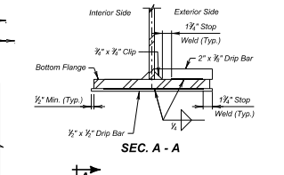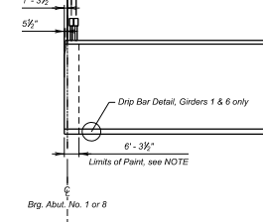

- Any recommended paint intervals on bridges? Multiple states noted that zone painting is used to get more out of budget. Wisconsin found that spot painting can almost cost just as much then to paint the entire structure. Illinois noted that on wider structures with 18 plus beams this isn’t necessarily true.

- Paint provider noted the new product of organic zinc that you can overcoat after 30 plus years. Helps to avoid the abrasive blasting on girders regularly used to remove paint and helps preserve longer.

